# Lab Week 6 (Assignment 2) – Using INT 21h/AH=1, AH=2, AH=9

## Objectives

In this lab, students will execute given sample programs to understand their working and observe their output. In this lab, students are assigned a programming exercise related to what they have learned in previous labs.

## Lab Tasks

**Task 1:** Write a program to (a) display a “?”, (b) read two decimal digits whose sum is less than 10, (c) display them and their sum on the next line, with an appropriate message, (d) in the end of your program display smiley face.

*Sample Execution:*

?27

THE SUM OF 2 AND 7 is 9.

**Task 2:** Write a program to (a) prompt the user, (b) read first, middle, and last initials of a person’s name, and (c) display them down the left margin, (d) terminate your program with beep sound.

*Sample Execution:*

Enter three initials: JKF

J

K

F

***Task-1:***

org 100h

.MODEL SMALL

.DATA

MSG db 'The SUM of$'

msg2 db ' And$'

msg3 db ' is$'

.CODE

MAIN PROC

mov ax,@DATA

mov ds,ax

mov ah,2

mov dl,'?' ;print the ? on screen

int 21h

mov ah,1

int 21h

mov bl,al ;store 1st input

mov ah,1

int 21h

mov bh,al ;store 2nd input

mov cl,bh

add cl,bl ;store the sum

mov ah,2

mov dl,0Ah

int 21h

mov ah,2

mov dl,0Dh

int 21h

lea dx,MSG

mov ah,9

int 21h

mov ah,2

mov dl,bl

int 21h

lea dx,msg2

mov ah,9

int 21h

mov ah,2

mov dl,bh

int 21h

lea dx,msg3

mov ah,9

int 21h

mov ah,2

sub cl,48

mov dl,cl

int 21h

mov ah,2 ;to display smiley face

mov dl,1h

int 21h

ret

***Output:***

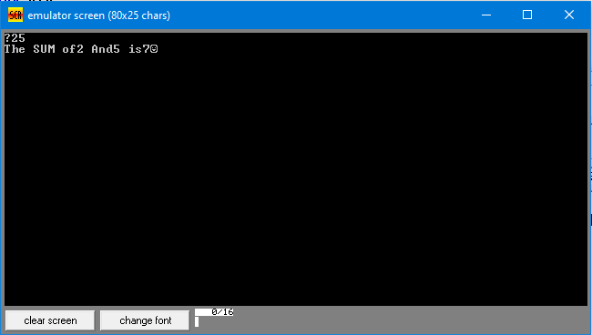

***Task-2:***

org 100h

.MODEL SMALL

.DATA

MSG db 'Enter three initials$'

.CODE

MAIN PROC

mov ax,@DATA

mov ds,ax

lea dx,MSG

mov ah,9

int 21h

mov ah,1

int 21h

mov bl,al

mov ah,1

int 21h

mov bh,al

mov ah,1

int 21h

mov cl,al

mov ah,2

mov dl,0Ah

int 21h

mov ah,2

mov dl,0Dh

int 21h

mov ah,2

mov dl,bl

int 21h ;first letter

mov ah,2

mov dl,0Ah

int 21h ; next line after first letter

mov ah,2

mov dl,0Dh

int 21h

mov ah,2

mov dl,bh

int 21h ;second letter

mov ah,2

mov dl,0Ah

int 21h ; next line after second letter

mov ah,2

mov dl,0Dh

int 21h

mov ah,2

mov dl,cl

int 21h ;third letter

mov ah,2

mov dl,0Ah

int 21h ; next line after third letter

mov ah,2

mov dl,0Dh

int 21h

mov ah,2

mov dl,7h ;beep sound

int 21h

ret

***Output:***

